# PRACTICAL 1

1. **Create a simple sequence based project**

A **Sequence** is a group of logical steps. Each step represents an action or a piece of work. A Sequence is used for processes that happen in linear succession, that is, one after the other. Among the three types of projects in UiPath, Sequences are the smallest.

1. On the Designer panel, drag and drop a Sequence activity from the Activities panel.

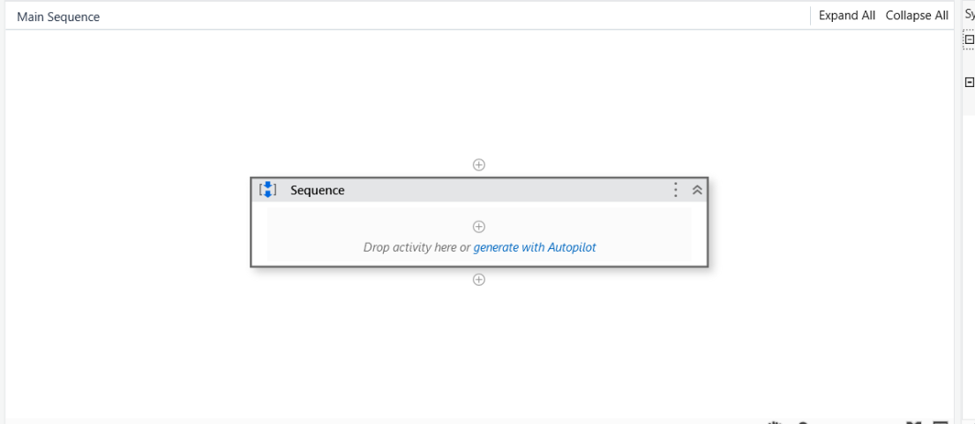

1. We will add two steps:
   1. Ask for the username in an Input dialog
   2. Display the username in a Message box
2. Drag and drop the Input dialog activity inside the Sequence .

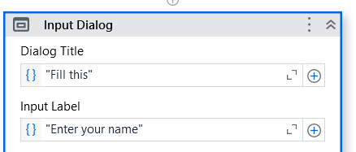

1. Drag and drop a Message box activity into the Sequence.

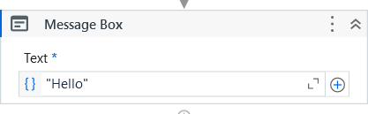

1. Next, create a variable and give it the desired name.

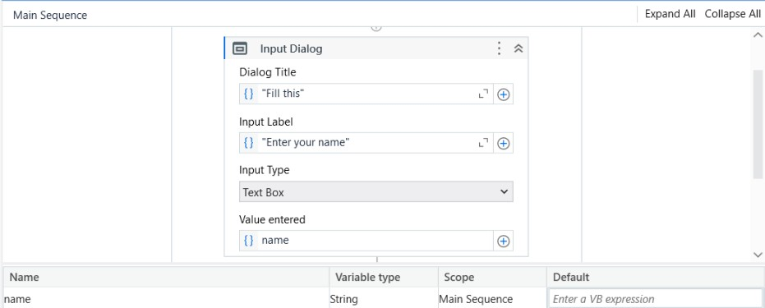

1. Specify the variable name that we have created in the Text area of the Message box

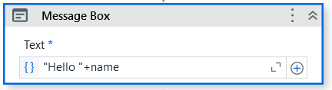

**Output:**

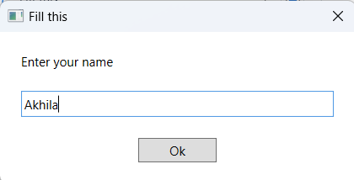

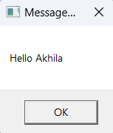



# Create a flowchart-based project.

A **Flowchart** is generally used for complex business processes. It provides decision-making facilities and can be used for both small and large projects.

* 1. First, add a Flowchart from the Activities panel into the Designer panel.

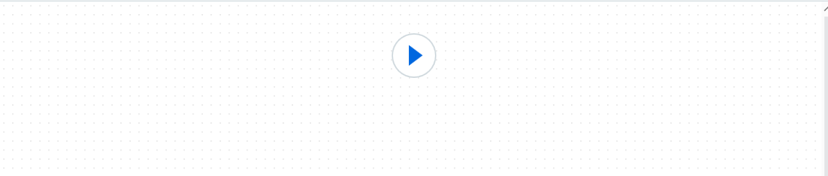

* 1. Create a variable and give default value as 1 .
  2. Add Flow Decision Activity

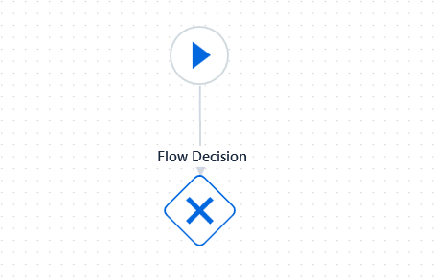

* 1. Add condition to the Flow Decision.

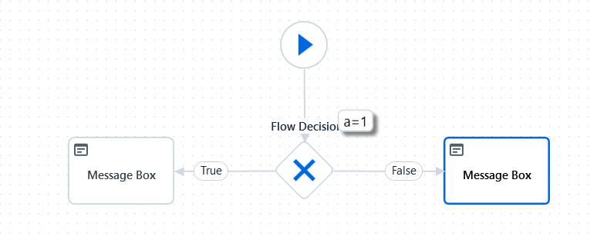

* 1. Add two message box one when the condition is True and one when the condition is False.

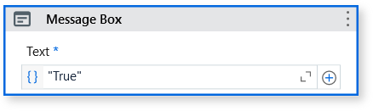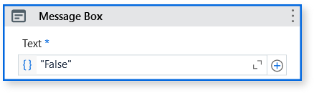

**Output :**

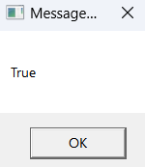

# Create an UiPath Robot which can empty a folder in Gmail solely on basis of recording.

We are going to record all the actions that have to be performed to empty this Trash folder so that our Robot understands the sequence to be performed.

1. Use Activity “Attach Browser” or “Use Application/Browser” and indicate the mail screen. Now start the recording

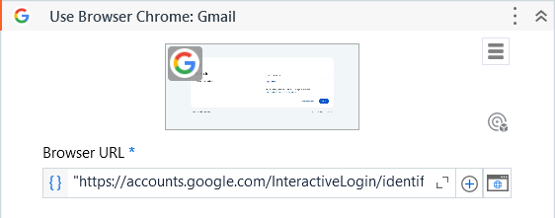

1. Another Activity will be “Type Into” to type the email id.

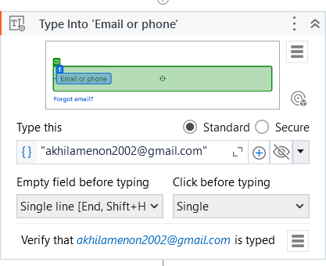

1. Use “Click” Activity to indicate the “Next” button.

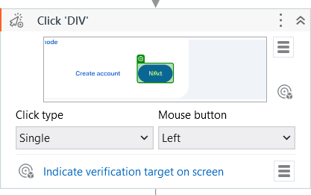

1. “Type into” Activity. Type the password. Click on eye button to hide the password.

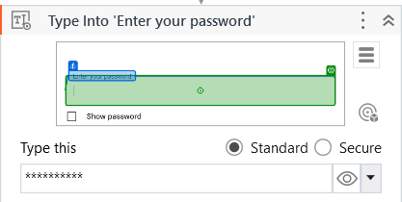

1. Use “Click” Activity to indicate the “Next” button.

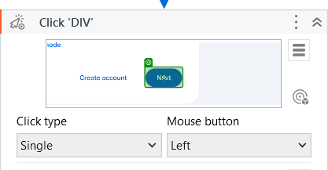

1. Now indicate the “More” and confirm the target.

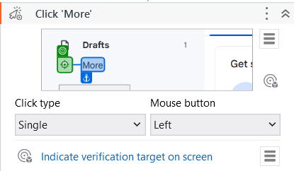

1. Target the “Trash” button.

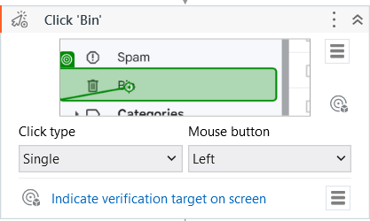

1. Use “Click” Activity to Empty the bin

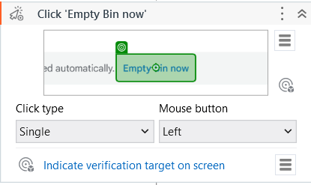

1. Use “Click” Activity to Press OK.

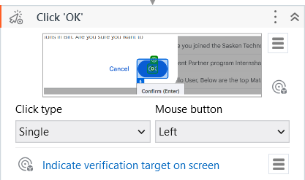

**Output :**

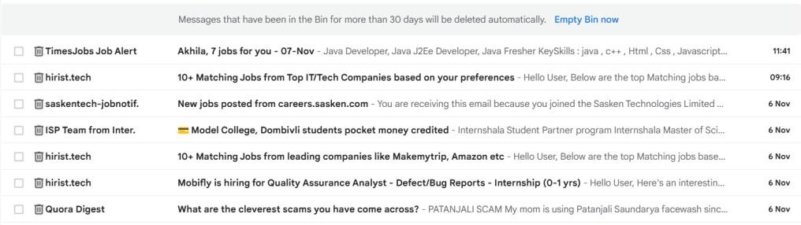



**PRACTICAL 2**

1. **Automate UiPath Number Calculation (Subtraction, Multiplication, Division of numbers).**

The **Switch** activity can be used to make a choice.By default, the Switch activity takes an integer argument. If we want to take a desired argument, then we can change it from the Properties panel, from the TypeArgument list. The Switch activity is very useful in the categorization of data according to one's ownchoice.

* 1. Create variables for this project .

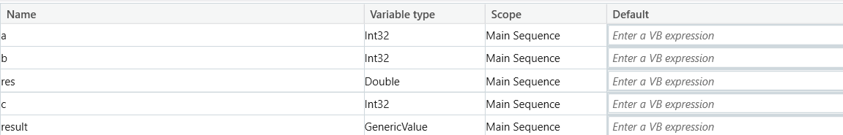

* 1. Drag and drop the Input dialog activity inside the Sequence to ask the user to enter an number and save it in variable named a.

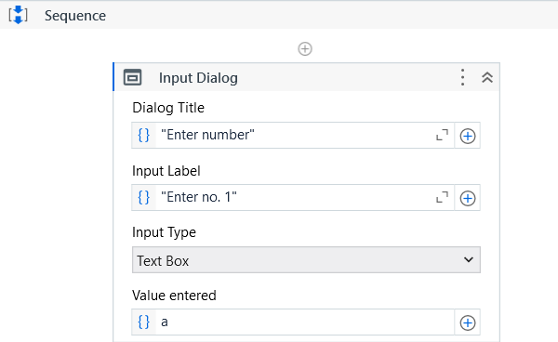

* 1. Add an input dialog activity to ask for the operation to perform.

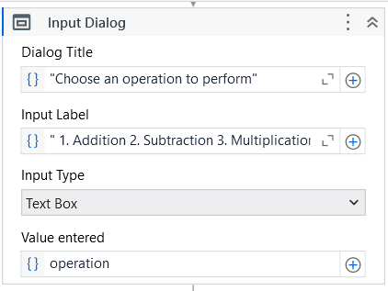

* 1. Add another input dialoge activity to store the second number.

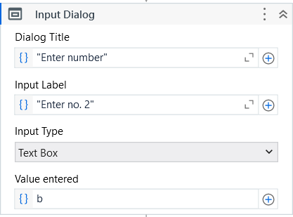

* 1. Add Switch activity to check which case is mentioned by the user and perform that operation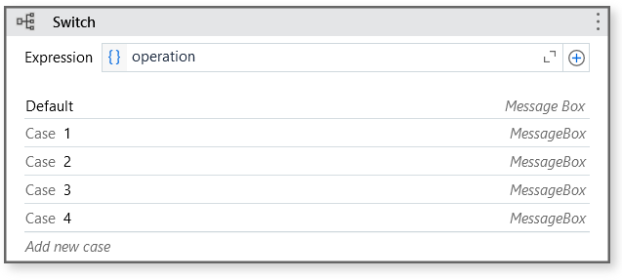

**Output:**

Addition :

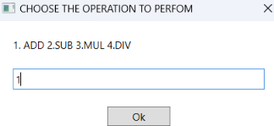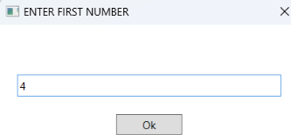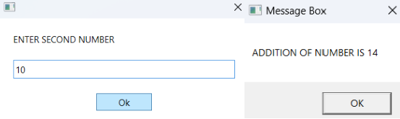

Subtraction :

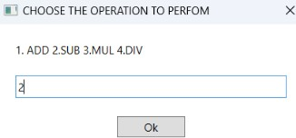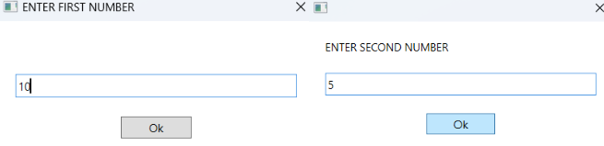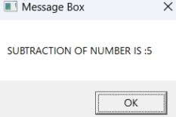

Multiplication :

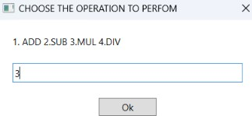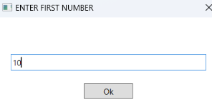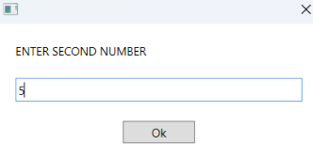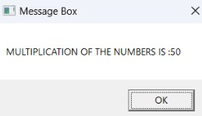

Division :

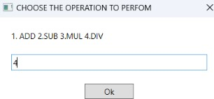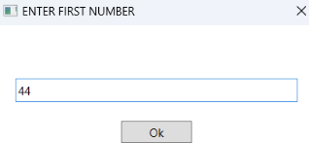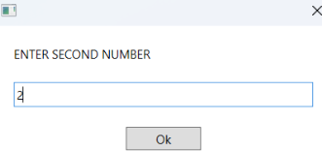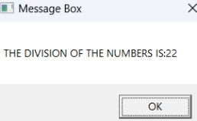

## Create an automation UiPath project using different types of variables (number. datetime, Boolean, generic, array, data table)

**NUMBER**

The **Assign** activity is used to designate a value to the variable. The Assign activity can be used for different purposes, such as incrementing the value of a variable in a loop, or using the results of a sum, difference, multiplication, or division of variables and assigning it to another variable.

1. Use three Input Dialog Activity to get three number’s from user

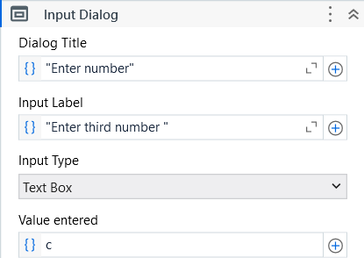

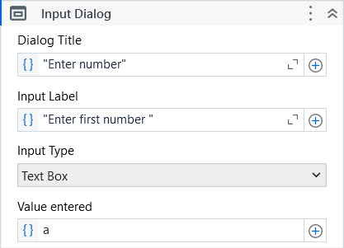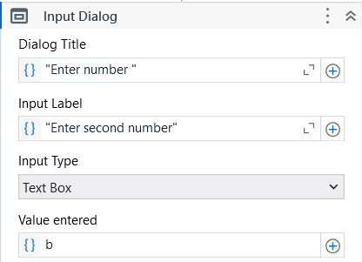

1. Use Assign Activity

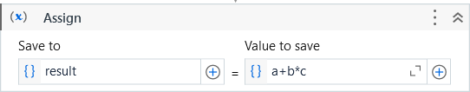

1. Add Message Box Activity to display the result

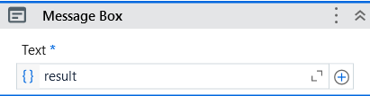

**Output :**

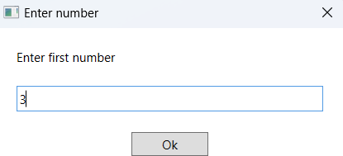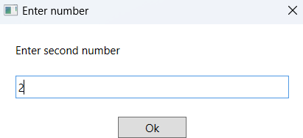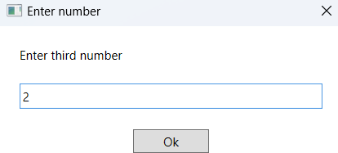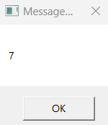

**DATETIME**

1. Create a variable of datatype DateTime.



1. Drag and drop assign activity and assign value to a .

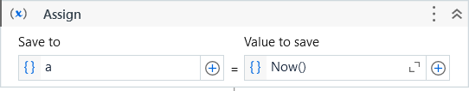

1. Add a Message Box to show the current Date and Time

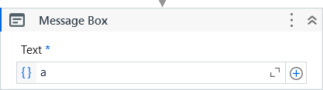

**Output :**

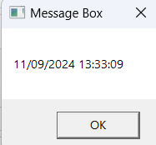

**BOOLEAN**

1. First, add a Flowchart from the Activities panel into the Designer panel.



1. Add two input dialogue to get two numbers from user .

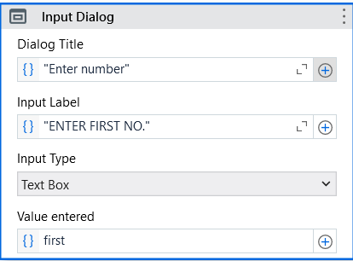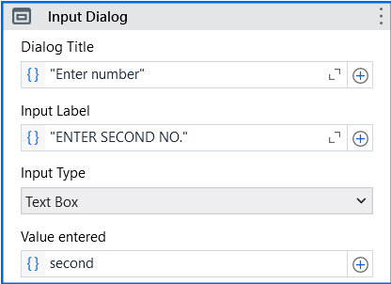

1. Now add Flow Decision , to check if the first entered number is greater than the second entered number .
2. Create a booleen variable to store the value in assign activity . So if the number is greater it would return True in the Message box else False

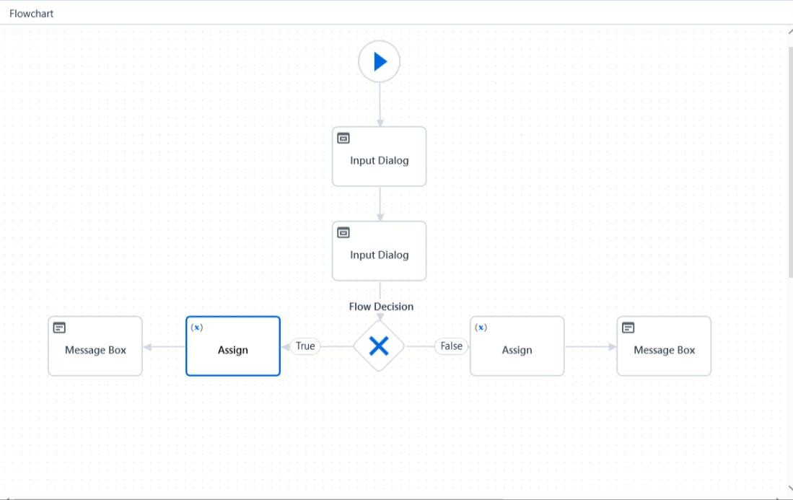

**Output :**

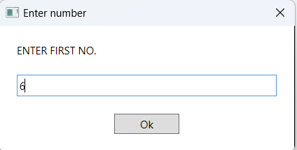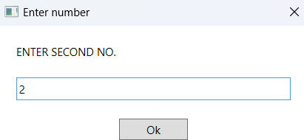

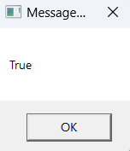

**GENERIC**

1. Create three variables of datatype Generic .

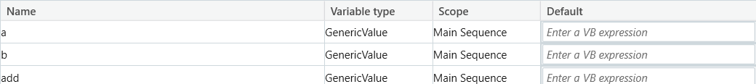

1. Add an “Input Dialog” to and get a “String” datatype value from user .

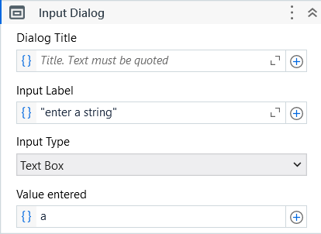

1. Add an “Input Dialog” to and get an “Integer” datatype value from user .

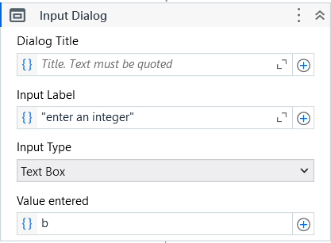

1. Use “Assign” Activity

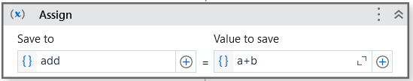

1. Use “Message Box “ Activity

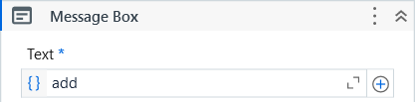

## Output :

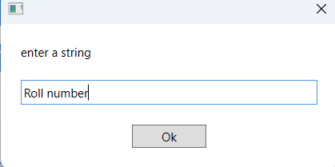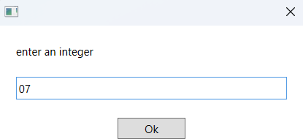

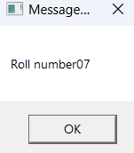

**ARRAY**

1. Drag and drop a sequence activity .

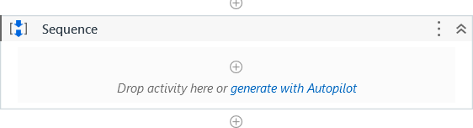

1. Create a variable of datatype array of String and set default values containing many ‘0’.



1. Create a count variable



1. Inside Sequence add For each Activity

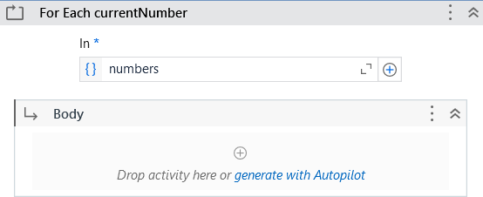

1. Add If activity inside the body and add the condition

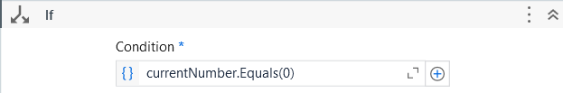

1. Add Assign Activity

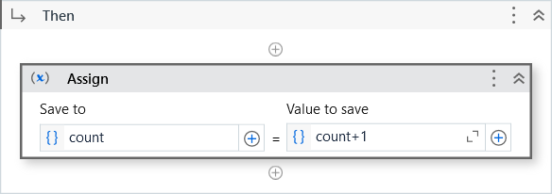

1. Add a Message Box to display the count

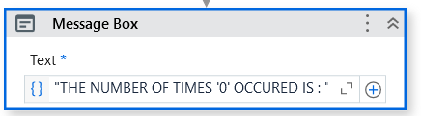

**Output :**

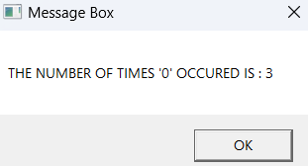



**DATATABLE**

A **data table** is a tabular form of data structure. It contains rows and each row has columns. A data table is used for various purposes. Say, for example, you have to build a table dynamically. You can use a data table as your preferred choice. A data table is also extensively used to store tabular data structures. In data scraping, data tables are widely used.

1. Drag and drop “Build Data Table” Activity.

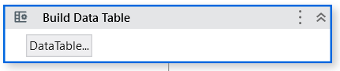

1. Click on the “Data Table” button and create a data table

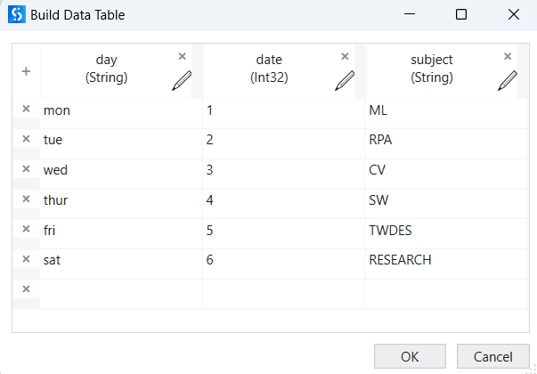

1. Create a variable of type datatable
2. Store the output value of the datatable in this variable



1. Use “Output Data Table as Text” Activity

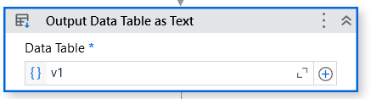

1. Create a variable of datatype String and store the value to the output property .





1. Add a Message Box to display the table .

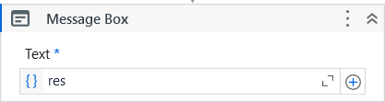

**OUTPUT:**

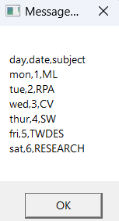

## PRACTICAL 3

1. **Create an automation UiPath Project using decision statements**

The **If activity** consists of a statement with two conditions: true or false. If the statement is true, then the first condition is executed; if not, the second condition is executed. This is useful when we have to take decisions on the basis of statements.

* 1. Drag and drop Input Dialog activity inside the main sequence and ask user to enter a number and store it in a variable named a .

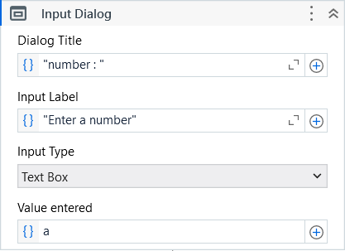

* 1. Now drag and drop if else activity to check whether the entered number is even or odd.

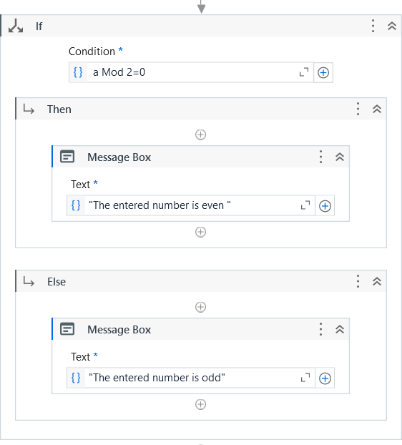

**Output:**

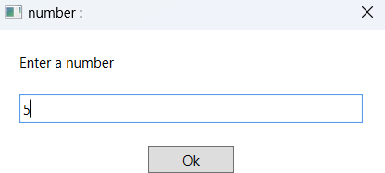

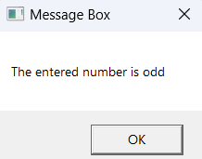

## Create an automation UiPath Project using looping statements.

The **Do while** activity is used in automation when it is required to execute a statement based on the fulfillment of a certain condition. How it differs from the While activity is that it executes a statement, then checks whether the condition is fulfilled. If the condition is not fulfilled, it exits the loop.

* 1. Drag and drop do while loop inside the Sequence Activity The condition on the while loop must be that it should prompt the input dialog box until user enters an even number .

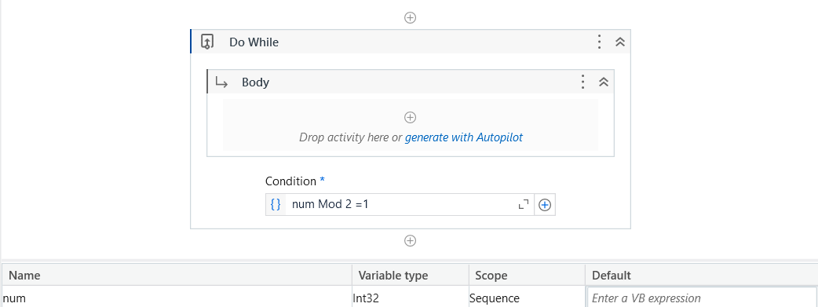

* 1. Add Input Dialog Activity

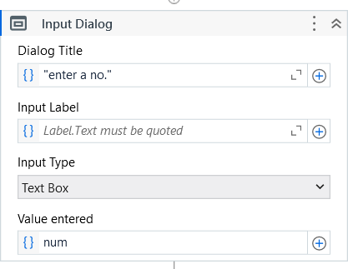

* 1. Add if else activity .In if, state this condition

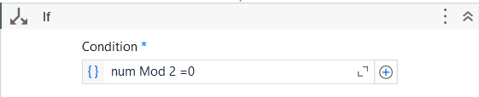

* 1. Add Message Box Activity

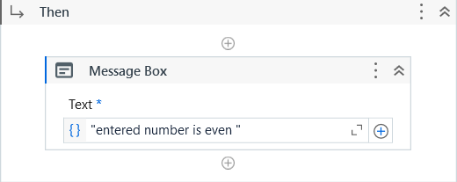

* 1. Add a Message Box Activity in Else .

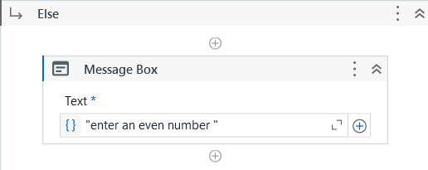

**Output:**

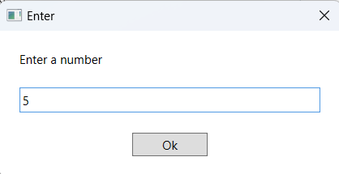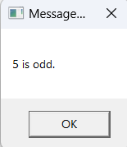

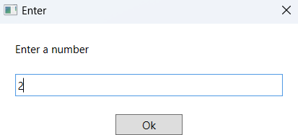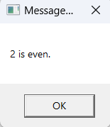

# PRACTICAL 4

**Automate any process in Basic, Web and Desktop Recording.**

1. Open UiPath Studio, add the activity “Use Application/Browser”. Select the chrome browser tab.
2. Start the Recording, Select type into and type “amazon.in”.

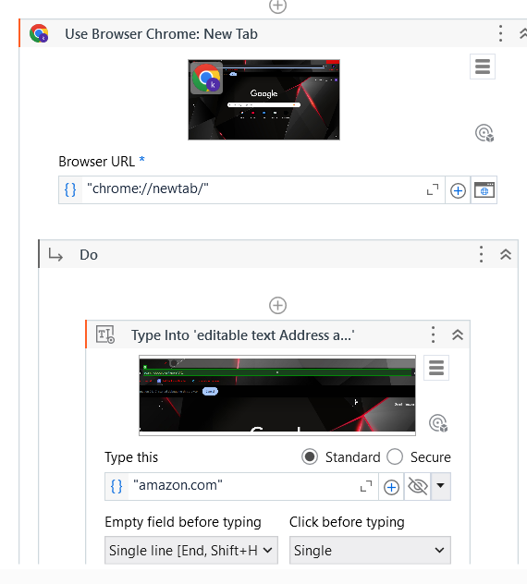

1. Now tap on “Enter” button to get recorded.

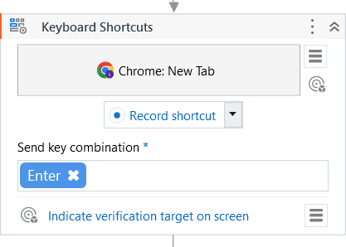

1. Select the Search bar while recording and type “Oneplus”.

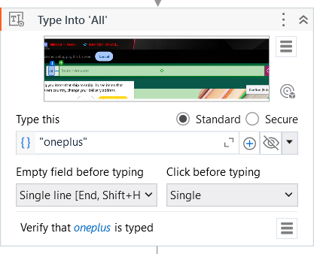

1. Now tap on “Enter” button to get recorded.

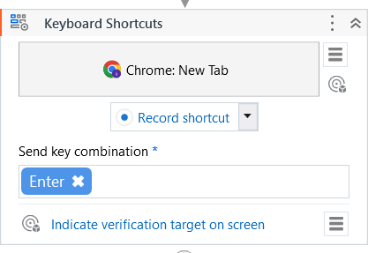

1. Again, add the activity “Use Application/Browser”. Now locate the amazon page.

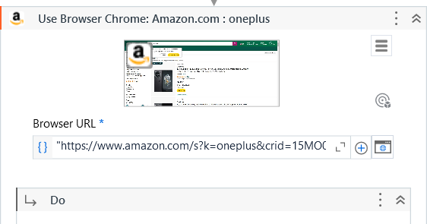

1. Select Table Extraction to store the data in datatable.

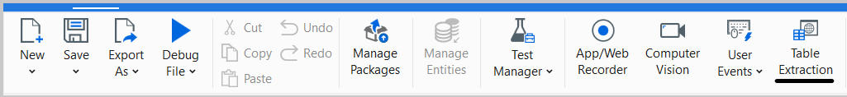

1. Data gets stored in datatable and the variable type will be “System.data.datatable” in ExtractDataTable.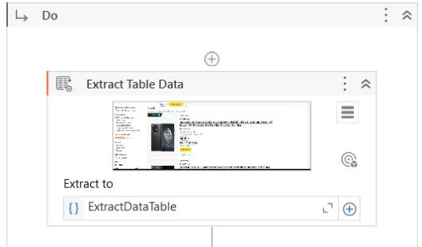
2. Add the activity “Output Data Table as Text”.

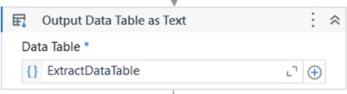

Its Properties:

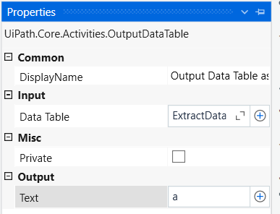

1. Add a “Message Box” activity.

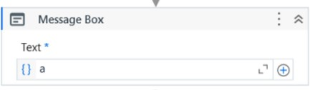

**OUTPUT:**

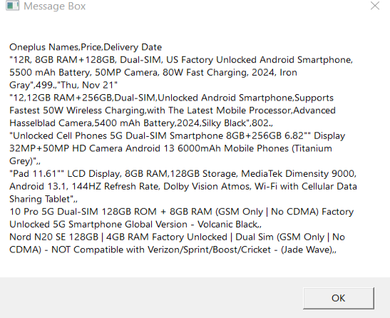

**PRACTICAL 5**

**A. Consider an array of names. We have to find out how many of them start with the letter "a". Create an automation where the number of names starting with "a" is counted and the result is displayed.**

The **For each** activity works by iterating each element from the collection of items or list of elements, one at a time. In the process, it will execute all the actions that are available inside the body. Thus, it iterates through the data and processes each piece of information separately

1. Drag and drop a Flowchart activity from the Activities panel
2. Drag and drop a Sequence activity inside the Flowchart.

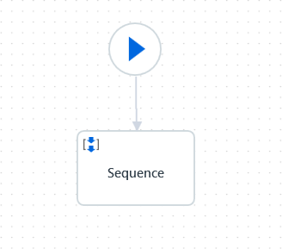

1. Double click on the Sequence activity. Create a variable.

Also, initialize the array in the Default section of the variable by giving it a default values

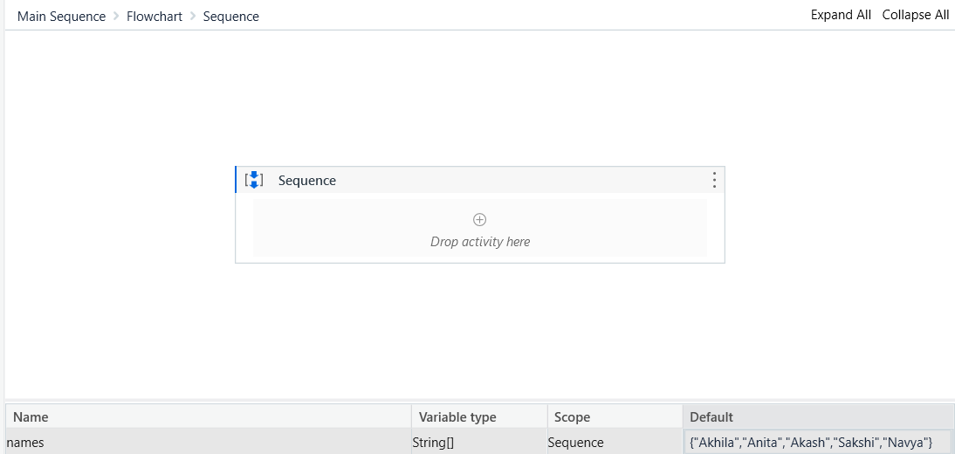

1. Drag and drop a For each activity inside the Sequence. Also, specify the array name in the expression box of the For each activity.

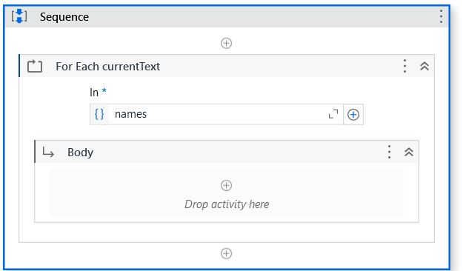

1. Drag and drop the If activity from the Activities panel and place it inside the For each activity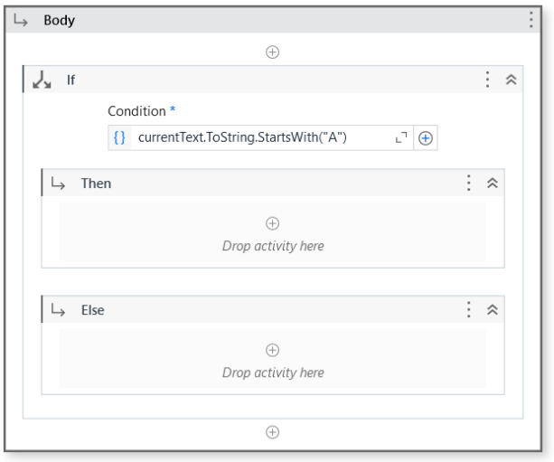
2. Just drag and drop a Write Line activity ,to get the output.

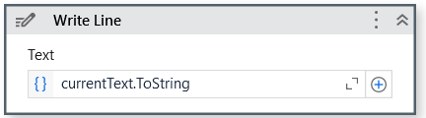

**Output:**

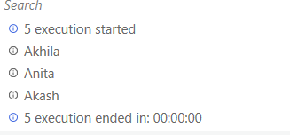

## PRACTICAL 6

1. **Create an application automating the read, write and append operation on excel file.**

**Read cell :**

We have a sample Excel file that we will use in this example

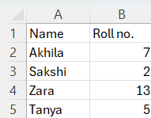

Suppose we have to read the value of the A2 cell:

1. Drag and drop a Sequence activity on the main Designer panel. Also, drag and drop an Excel application scope inside the Sequence. Double click on Excel application scope.

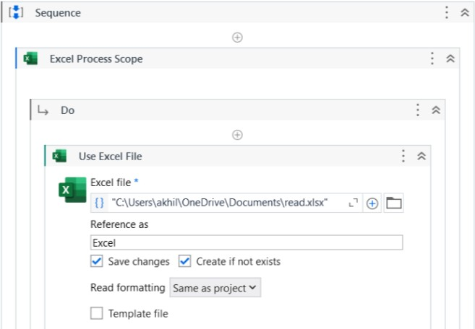

1. Drag and drop the Read Cell activity inside the Excel application scope activity. Specify the range value . Create a variable of type string to hold the result.Specify the Output property of the Read Cell activity by providing the variable's name
2. Drag and drop a Message box activity inside the Excel application scope activity and specify the string variable's name

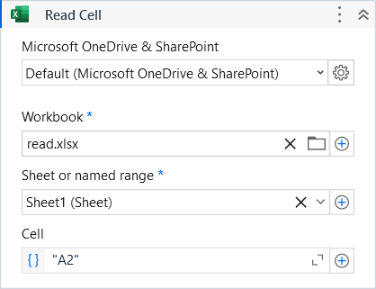

**Output :**

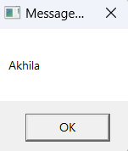

**Write cell :**

1. Drag and drop a Write Cell activity inside the Excel application scope. Specify the cell value in which we want to write in the Range property of the Write Cell activity. Also, specify the value of the Value property:

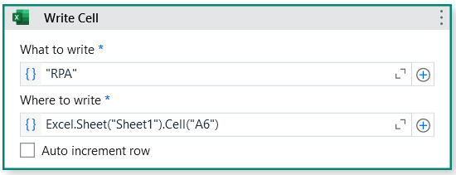

**Output :**

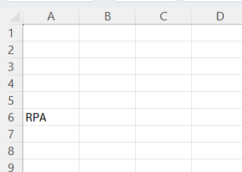

**Read range :**

1. Drag and drop a Read Range activity inside the Excel application scope activity. The Read Range activity produces a data table. We have to receive this data table in order to consume it. We need to create a data table variable and specify it in the Output property of the Read Range activity.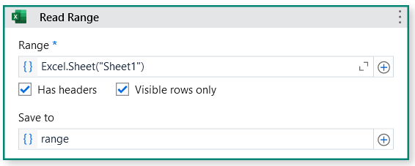
2. Drag and drop an Output Data Table activity inside the Excel application scope activity. Now, we have to specify two properties of the Output Data Table activity: Data Table property and text property. The Data Table property of the Output Data Table activity is used to convert the data table into a string format.

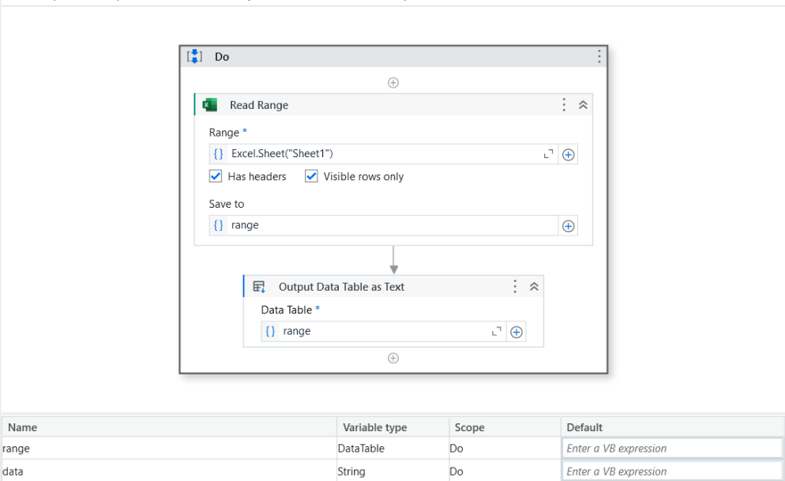

1. Add a message box to show the output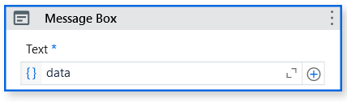

**Output :**

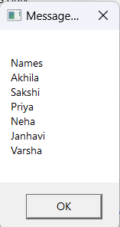

**Write Range :**

1. Drag and drop a Build data table activity from the Activities panel.

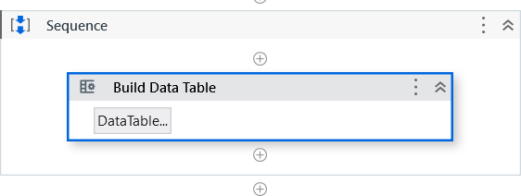

1. Add your column by clicking on the + icon and specify the column name

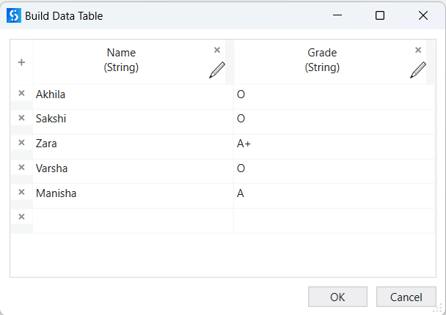

1. Drag and drop an Excel application scope.Inside the Excel application scope activity, just drag and drop the Write Range activity.

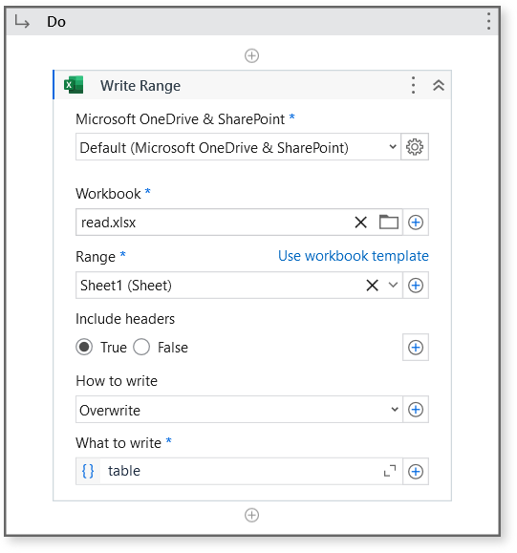

**Output :**

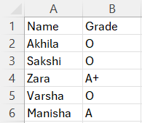

**Append Range :**

The Append Range activity requires a data table. For example :

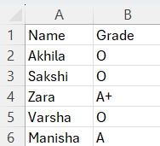

Then, we will read this Excel file and append the data to another Excel file.

1. Drag and drop the Read Range activity inside the Excel application scope activity. The Read Range activity produces a data table. We have to receive this data table in order to consume it.

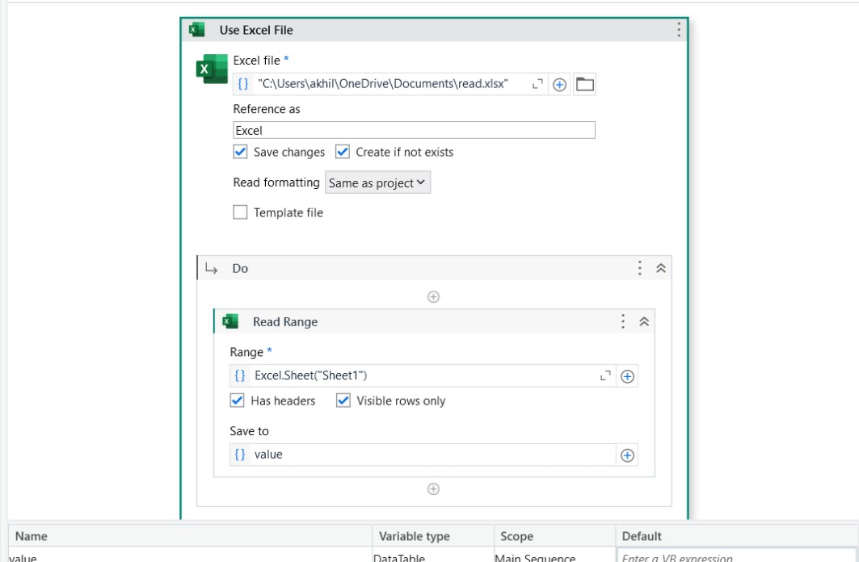

1. Create a data table variable and specify it in the Output property of the Read Range activity
2. Drag and drop the Append Range activity .And drop the Append Range activity inside the Excel application scope activity. Specify the Excel file path in the Append Range activity. Also, specify the data table .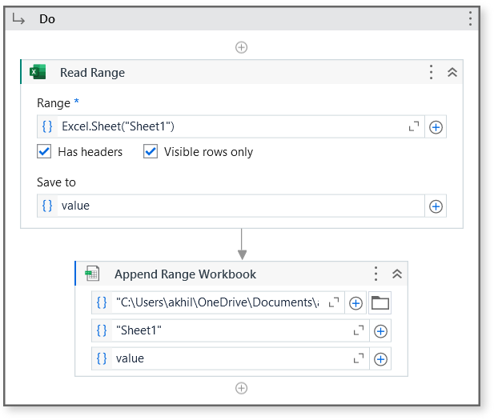

**Result :**

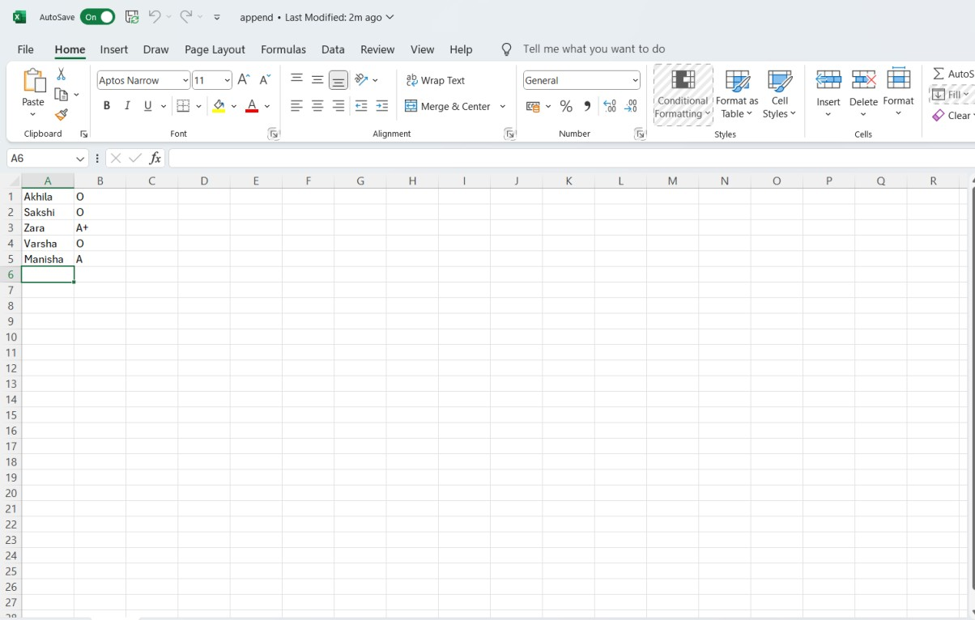

## Automate the process to extract data from an excel file into a data table and vice versa

**EXCEL FILE TO DATATABLE**

The **Read Range Workbook** Activity ,reads the value of an Excel range and stores it in a DataTable variable. If the range isn't specified, the whole spreadsheet is read. If the range is specified as a cell, the whole spreadsheet starting from that cell is read.

1. Drag and drop Flowchart Activity .



1. Add Read Range Workbook Activity

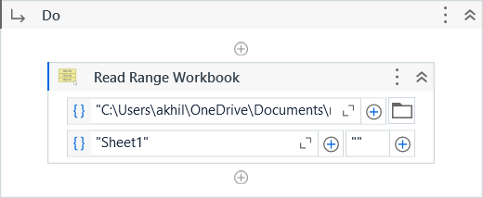

1. Set the Output Property of the “Read Range Workbook” Activity to datatype DataTable



1. Drag and drop “Output DataTable as Text”

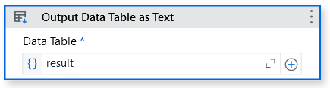

1. Set it’s Output Property to a variable String datatype

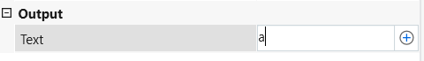

1. Add a “Message Box” to show the result.

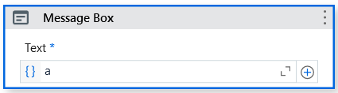

**Output:**

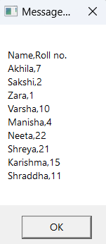

**DATATABLE TO EXCEL**

The **Write Range Workbook**,writes the data from a DataTable variable in a spreadsheet starting with the cell indicated in the StartingCell field. If the starting cell isn't specified, the data is written starting from the A1 cell. If the sheet does not exist, a new one is created with the SheetName value. All cells within the specified range are overwritten. Changes are immediately saved.

1. Drag and drop “Build Data Table” Activity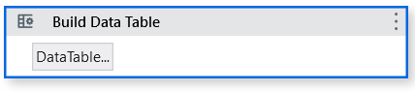
2. Click on the DataTable and create a Data Table.

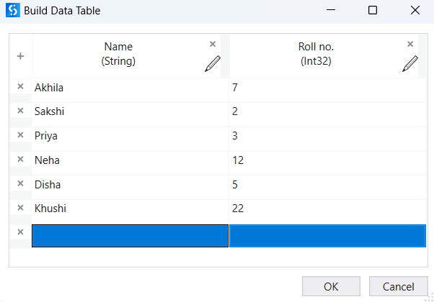

1. Create a variable of datatype DataTable and set it to it’s Output property



1. Use “Write Range Workbook” Activity

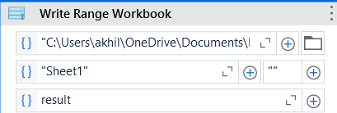

**Output :**

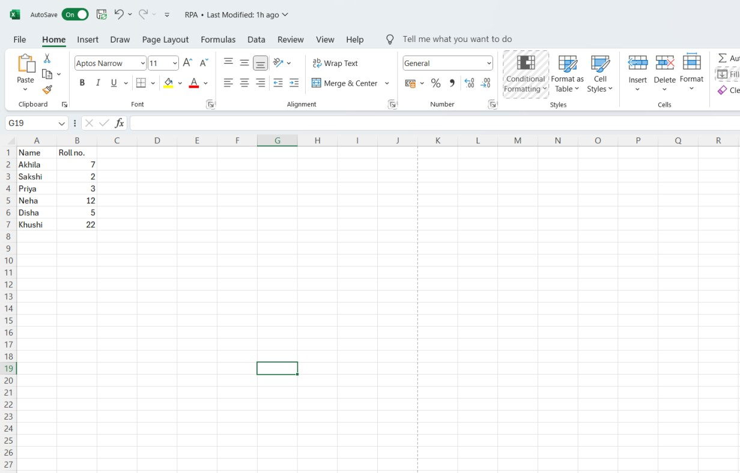

## PRACTICAL 7

**Demonstrate the following activities in UiPath:**

## Mouse (click, double click and hover)

Click Activity

When we have to click on a UI element on the screen, we generally use the Click activity. It is very easy to use the Click activity,

* + 1. Drag and Drop a Sequence on the Designer Panel
    2. Drag and Drop the Click Activity . Click on indicate on screen and indicate the UI element you want to click on .
    3. Hit the Run Button to see the result .

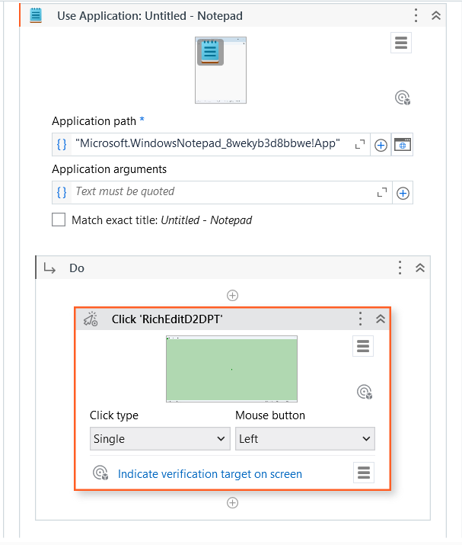

Double - click Activity

The Double Click activity is similar to the Click activity. It just performs the double-click action. Using the Double click activity in your project is almost the same as click. You have to use the Double click activity instead of the Click activity and indicate the UI element.

2. Drag and Drop a Sequence on the Designer Panel

1. Drag and Drop the Click Activity . Click on indicate on screen and indicate the UI element you want to click on .
2. Hit the Run Button to see the result .

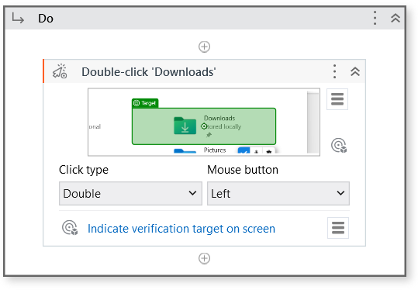

Hover

The Hover activity is used to hover over a UI element. Sometimes, we have to hover over a UI to perform an action.

* 1. **Type into**

The **Type into** activity is quite similar to the **Send hotkey** activity. We have to send the keystrokes along with the special keys. Special keys are optional.

* + 1. Drag and Drop Type into Activity
    2. Specify the keystrokes and the special keys by clicking on the + icon and choosing the key from the drop-down list.
    3. Indicate on screen the area where you want the text to be typed.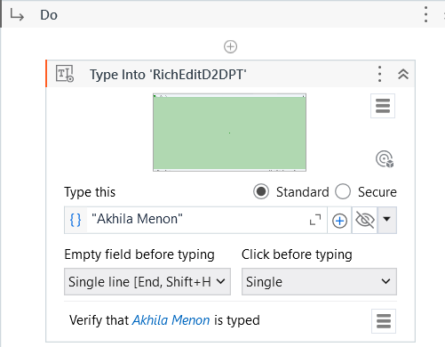
  1. **Type Secure text**

The **Type Secure text** activity is used to send secure text to the UI element. It sends the string in a secure way.

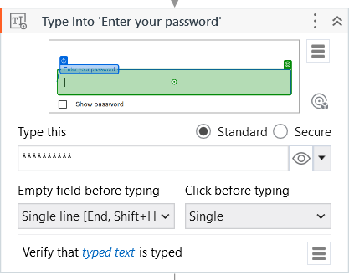

## PRACTICAL 8

**A. Demonstrate the following events in UiPath:**

## Element triggering event

This type of event deals with clicking and keypress events.

Before using the **Click trigger**, we have to use the Monitor events activity. Without Monitor events, the Click trigger cannot be used.

1. Drag and drop Trigger Scope and drop Click Event Trigger inside it.

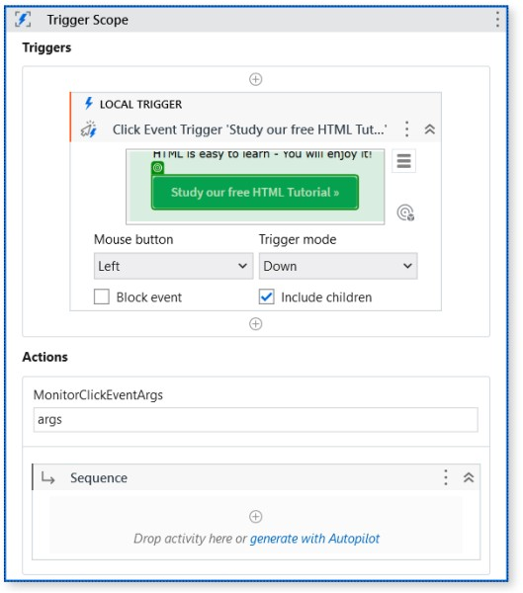

1. Start the recording and perform the following steps
2. Open notepad and type “hello”

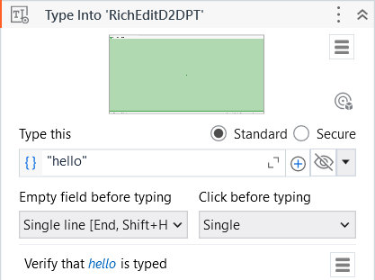

1. Click on edit with anchor

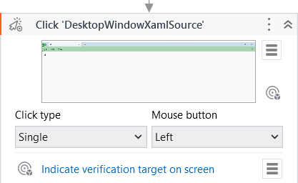

1. Click on ‘Save as’.

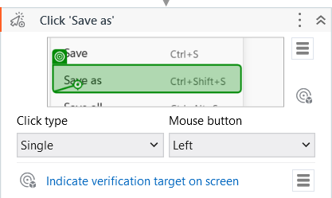

1. And save the file by clicking Save

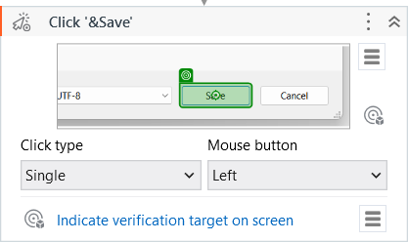

When the Click action is performed on the specified button, then the event handler will be called and the activities inside the event handler will be executed.

1. **Image Trigger**

The **Click image trigger** is an image tiriggering event. Click image trigger, as the name suggests, is used for when we click an image. You just have to use the Click image trigger event inside the Monitor event and indicate the image. Upon clicking the indicted image in the Click image trigger event, the event handler will be called.

1. Drag and drop “Trigger Scope” inside it add “Click Image Trigger”

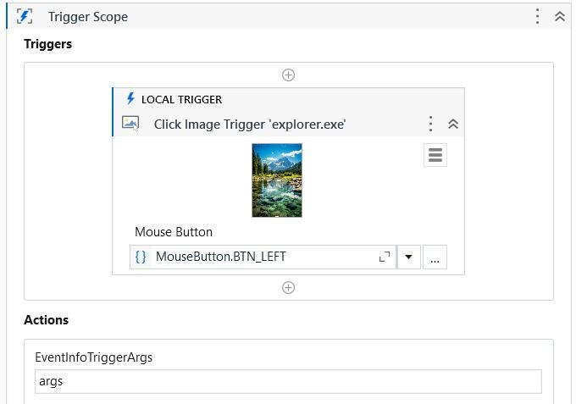

1. Start recording and perform the following steps.
2. Open notepad and type “hello”



1. Click on file with anchor



1. Click on ‘Save as’.



7. And save the file by clicking Save



## System Triggering Event

The **Hotkey Trigger** event is raised when special keys are pressed. As we have already looked at triggering events, you can use the Hotkey trigger event on your own. You have to use this event inside the Monitor event. Specify the special key or combination of keys. Also, provide the event handler that will be called when the event occurs.

1. Drag and drop “Trigger Scope” inside it add “Hotkey Trigger”

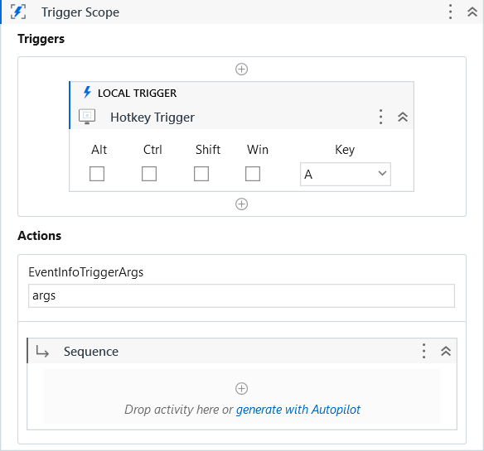

1. Start recording and perform the following steps.
2. Open notepad and type “hello”



1. Click on file with anchor



1. Click on ‘Save as’.



1. And save the file by clicking Save



## PRACTICAL 9

* 1. **Automate the process of send mail event (on any email).**
     1. Use Activity “Attach Browser” or “Use Application/Browser” and indicate the mail screen. Now start the recording.

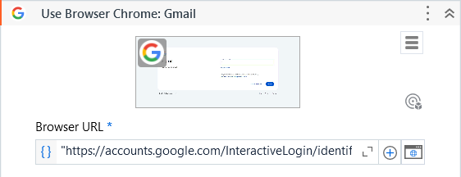

* + 1. Below all activities are save in flow automatically when recording is done.

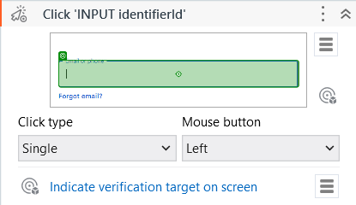

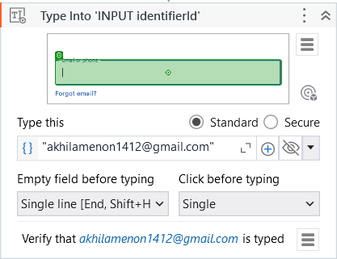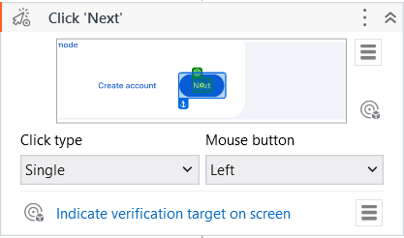

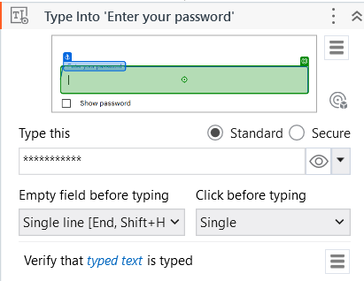

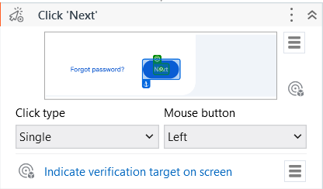

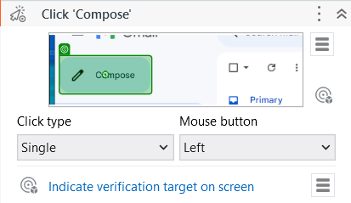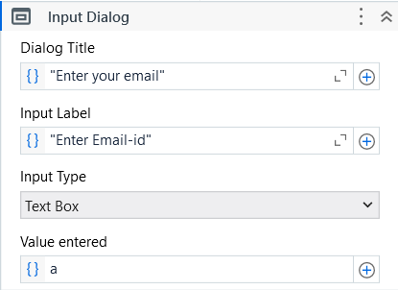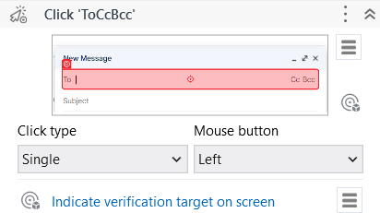

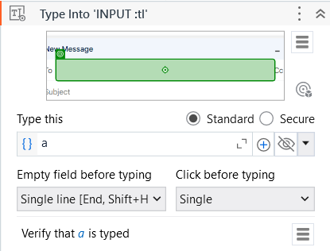

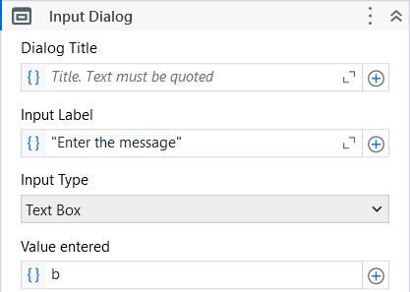

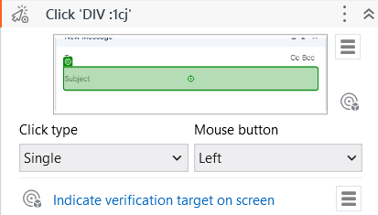

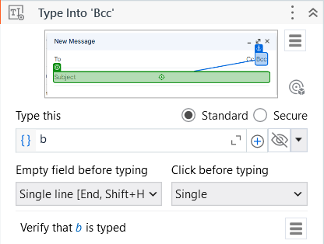

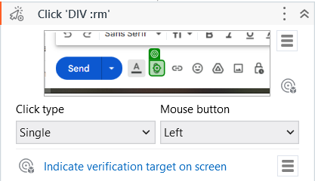

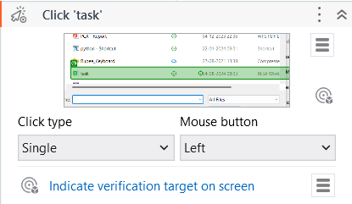

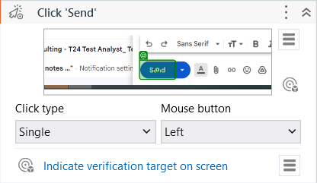

* + 1. Add a “Message Box” Activity

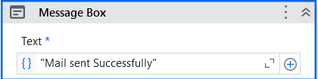

**Output :**

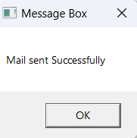



## Demonstrate the Exception Handling in UiPath.

The **Try catch** activity can be found in the Activities panel. By dragging and dropping theTry catch activity into the workspace, we can handle exceptions. For handling errors in the

Try catch block, we can divide the whole process into four parts just to make it simpler.

**Step1 :** Start the recording.

* Click on “**Notepad**”.

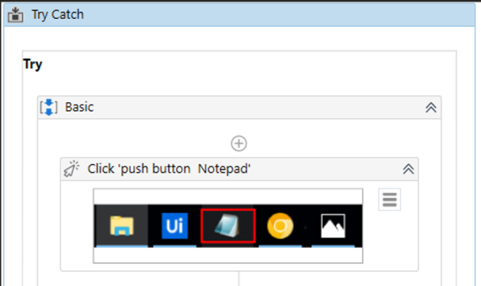

* While on Recording, select “**Type Into**” and add the text “**Event Trigger in Ui path**”.

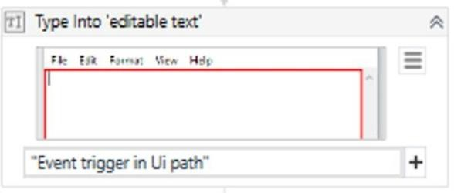

* Indicate the “Edit” while recording session.

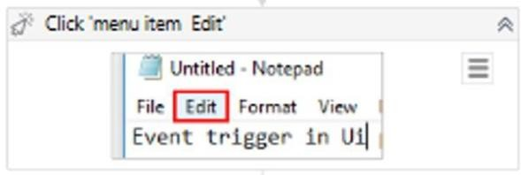

* Indicate the “**Select All**” while recording.

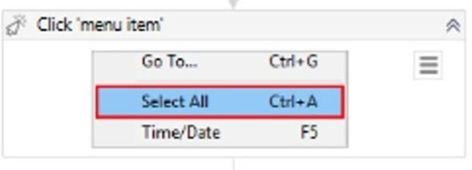

* Indicate the “**Format**” and “**Font**” while recording.

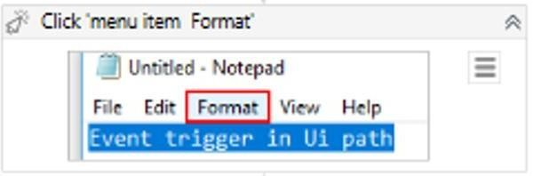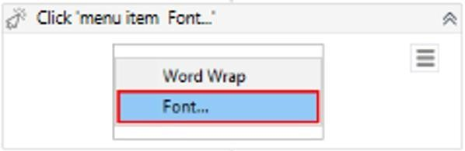

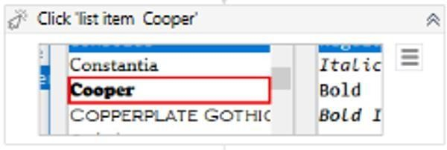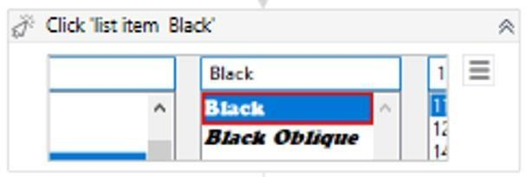

* Indicate the “Font”, “Font Style” and “Size” while recording.
* Indicate the “**OK**” button while recording and add delay activity then add the time.

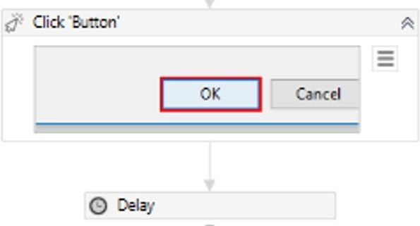

**Step 2:** Now save the recorded file. After recording change the font and run the file.

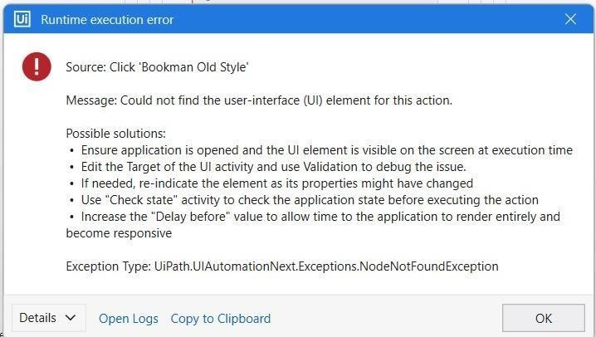

**Step 3:** Now in Catch add the exception type: “**UiPath.AutomationNext.Exceptions.NodeNotFoundException”**.

**Step 4:** Now add the same activity in catch.

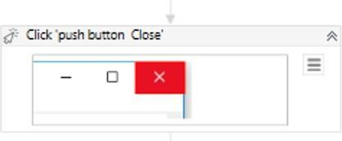

* Click on “**Notepad**”.



* While on Recording, select “**Type Into**” and add the text “**Event Trigger in Ui path**”.



* Indicate the “Edit” while recording session.



* Indicate the “**Select All**” while recording.



* Indicate the “**Format**” and “**Font**” while recording.



* Indicate the “Font”, “Font Style” and “Size” while recording.





* Indicate the “**OK**” button while recording and add delay activity then add the time.



**Step 5:** Add a message box, in the final to display it after the output.

**Step 6:** Now run the activity it will perform as per the recording session. Later it will display the message after the completion of recording.

**OUTPUT:**

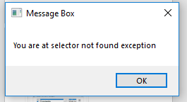

## PRACTICAL 10

**b. Automate any process using State Machine in UiPath.**

A **State Machine** uses a finite number of sets in its execution. It can go into a state when it is triggered by an activity; it exits that state when another activity is triggered. Another important aspect of State Machines is transactions. They enable you to add conditions based on which transactions jump from one state to another. These are represented by arrows or branches between states.

1. Drag and drop State Machine Activity

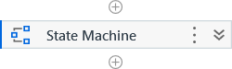

1. Add a State Activity to get user input

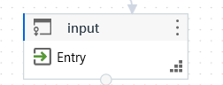

1. Inside the input State add two Input Dialog Activity

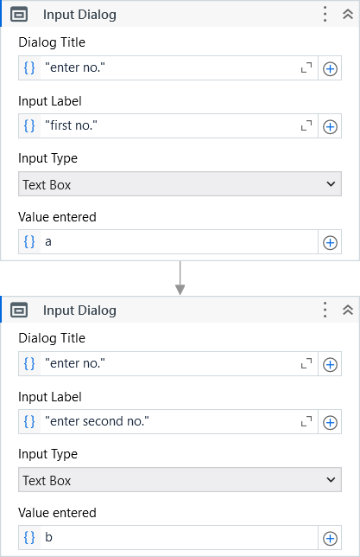

1. Add State named Process which would connect three State : Multiply , Divide and Subtract

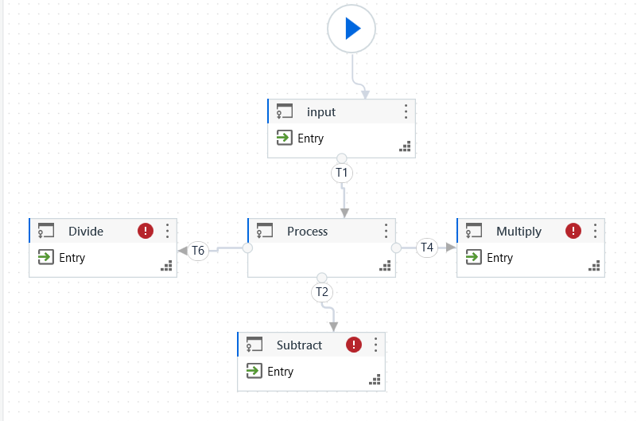

1. Add condition in the transaction

For Divide :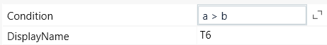

For Multiply : 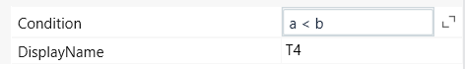 For Subtract : 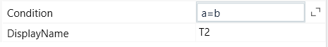

1. Add FInal State Activity

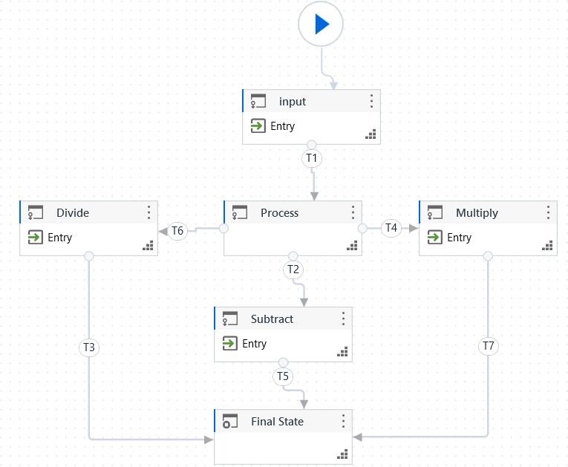

**Output :**

Division-

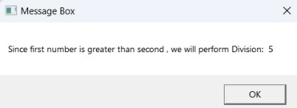

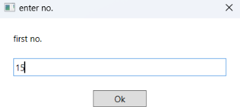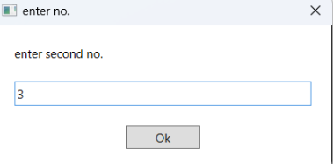

Subtraction -

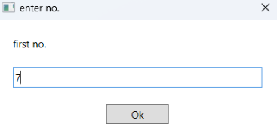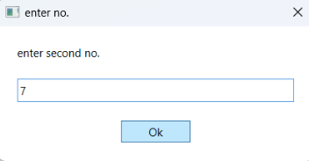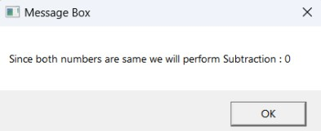

Multiplication -

